EMPLOYEE MANAGEMENT SYSTEM USING SPRING BOOT

TABLE OF CONTENTS

No. | Title | Page No.
 | Abstract
1. | Chapter 1  Introduction | 1
1.1 | General Overview of the Problem | 2
2. | CHAPTER 2  Literature Survey
2.1 | Existing system | 3
2.2 | Proposed System | 4
3. | CHAPTER 3
3.1 | Problem Statement | 5
3.2 | Motivation | 6
3.3 | Objectives | 6
4. | CHAPTER 4  Methodology
4.1 | Architecture Diagram | 7
4.2 | Data Flow Diagram | 8
5. | CHAPTER 5  RESULT AND DISCUSSION | 9-13
6. | CHAPTER 6  Summary and Conclusion
6.1 | Summary of achievements | 14
6.2 | Difficultiesencountered during project | 14
6.3 | Limitations of the project | 14
6.4 | Future scope of the project | 14
6.5 | Conclusion | 15
7. | References | 16

ABSTRACT

Employee management system is an application based system, having two applications developed, one for employers to manage employee details and another for employees to mark their attendance. Every organisation whether government or private uses an information system[2.] to store data of their staff. However, in India it is found that many small scale industries use pen and paper to keep a record. However, there are many advanced technology systems available that can do this work but they all are costly for these low level industries. This paper discusses making a system for solving problems for them at a cheaper cost. This system will mark attendance of each employee and calculate the salary of them at the end of month. It also calculates overtime and total working hours of each employee. As in small scale each company has their own holidays preference and variable week off for employees, so all this power is given to the employer to manage holidays and week days of each employee separately. It saves lots of time and has no error in pay calculation hence preventing clashes between HR Team and employees. So that both employer and employee can focus on their work to develop their company.

CHAPTER 1

INTRODUCTION

The Employee Management System includes operations like adding new Employees into the Database, updating existing Employees, Delete Employees, Retrieving All Employees’ Data in the form of a Table and the final one is Delete All Employees. In This Article, we will learn about Employee Management systems such as EMP. Mostly This Spring boot web application handles the Employee data and performs different operations on each Employee record in the database.

The project has been designed to solve the problems, Which are likely to be faced by the employees of the department at the time of calculating the salary Details of employees.The project has covered almost all the necessary data, which is required for Employee Management System.The main purpose of the project is to save time,money and to remove heavy workload of the employees.

Organization, whether big or small,has human resource challenges to overcome.every organization has different employee management needs,therefore we design exclusive employee management system that are adapted to your managerial requirements.This is designed to assist in strategic planning,and will help you ensure that your organization is equipped with the right level of human resources for your future goals.Also,for those busy executive who are always on the go,our systems come with remote access features,which will allow you to manage your workforce anytime,at all times.These systems will ultimately allow you to better manage resources.One of the main features in employee management system is time tracking for employees.Effectivetime tracking mechanism saves both time and money for the organization.

Employee Management System Project is designed to keep track of employee information in any company. It stores data such as their employees' personal information leave details and salary details. The employee management system project gives managers a better idea of their employees and helps them plan and manage their work hours to cut costs and boost productivity. It gives appropriate directions and supervisions for employees. It also secures and manages information that are important to the employees including personal and work-related information. Employee management system is developed to manage the data and information of an employee in a company. It is developed to override the problems prevailing in the practicing manual system.

1

1.1 General Overview of the Problem

Due too many data and paperwork that needed to record the employee data could consume a lot of space in the filling cabinet. The retrieval of data can time consuming because it must be searched from the filling cabinet. This will cause waste of resource in term of time and money. In addition, it would also cause inconvenience and ineffectiveness in daily work. Plus, the manger will face difficulties when need to update employee working schedule, report and leave request.

In the employee point of view, when they need to request for leave, they need to fill in a leave request form manually and submit to manager personally and wait for confirmation, this is time consuming. Other than that, if there are any changes in working schedule, employee might have wrong information in the working schedule because the schedule might not update immediately, therefore the employee might not satisfy with the working schedule.

2

CHAPTER 2

LITERATURE REVIEW

2.1 EXISTING SYSTEM

The issue definition for planning the framework is to keep up with information of worker, to make simple controlling workers, to isolate occupations and access control of workers, to utilize innovation for exact and ideal handling by completely protection and full position access. The objective of the undertaking is to set up worker data framework about status of representative and participation of worker and month to month compensation interaction and conveyance. To kill or decrease however much as could reasonably be expected the difficulties of existing framework and keep away from blunders while entering information. In existing strategy representative administration are employee record are keeping up with in records. It's a manual cycle. Convoluted to look through the representative compensation Detriments: Needs for additional manual exertion. In existing framework is independent cycle typical worker can't follow their representative status.Less Accuracy Danger of losing a few documents. Certain necessary report isn't accessible Time-consuming measure.

- The records are maintained in registers.
- Time consuming process.
- Complicated searching,editing & updating.

3

2.2 PROPOSED SYSTEM

This part expands on the work done in the Analysis Part and gives documentation for the Design of the Representative Management System. The EMS is displayed in terms of articles and classes and their collaborations with one another. Clarification of the proposed framework is finished too design of the Entity Relationship Diagram (ERD). Plan of the User Interface is likewise talked about. The proposed framework is intended to dispense with all the disadvantages of the current representative administration programming. The framework will be liable for keeping up with data about representatives, subsequently their individual profile. The framework will join leave the executives right from application to acknowledgment/dismissal of leave demands just as all worker projects with close checking of the tasks from creation to finishing and trainings to aid checking dynamic and dormant representatives.

- Helps in maintaining the computerized employee details.
- Computerized Events & Requests Management.
- Create new users to the System accordingly.

4

CHAPTER 3

3.1 PROBLEM STATEMENT

Manual treatment of worker data represents a number of difficulties. This is obvious in methodology such as leave the board where a representative is needed to fill in a structure which might require a little while or months to be supported. The utilization of administrative work in taking care of some of these cycles could prompt human mistake, papers may end up in some unacceptable hands and not failing to remember the reality that this is tedious. Various current frameworks need worker self-administration meaning representatives are not ready to get to and deal with their own data straightforwardly without going through their HR offices or their administrators. Another test is that global organizations will have all the representative data put away at the central command of the organization making it hard to get to the representative data from remote spots when required at short notification. The previously mentioned issues can be handled by planning what's more, carrying out an electronic HR the board framework. This framework will keep up with worker data in a data set by completely protection and authority access. The project is pointed toward setting up worker data framework about the situation with the worker, the instructive foundation and the work insight to help screen the presentation and accomplishment of the worker through a secret key ensured framework. This report's documentation goes through the entire cycle of both application program and data set turn of events. It likewise contains the improvement devices have been used for these reasons. This framework should comprise of an application program, on one hand, and an information base (archive of information) on the other. The program ought to play out the fundamental tasks upon the data set as recovering, embeddings, refreshing and erasing information. Any extra usefulness is an objective of a further module improvement. It is a sort of system to begin the improvement from planning and developing the data set, as this construction will decide the further design of the application program. The intelligent data set model (tables, their substance and the connections between them) ought to react to the given errand and cover the fundamental prerequisites. The Interface of the program ought to be easy to use, and the program ought to be as simple for use as it is conceivable. Both controls and structures ought to coherently and practically be related inside the program and completely react to the design of the information base. Another issue is building up the associations with the information base, without fail, when an inquiry is should have been performed upon it. Exemption taking care of ought to likewise be considered during the framework's turn of events because of possible exemptions that might happen.

5

3.2 MOTIVATION:

- The primary concern of this Employee Management System project is to make a system which will help any organization to maintain the employee’s information.
- It will take lots of time to maintain the record manually.
- Employees are not able to see their leave status and payslip.

3.3 OBJECTIVES:

1. This project aims to simplify the task maintaining records of the employees of company.
2. To develop a well-designed database to store employee information.
3. To add, update and delete the records of an employee.

6

CHAPTER 4

METHODOLOGY:

DESIGN STRATEGY FOR THE SOLUTION:

4.1 Architecture Diagram:

Login
Enter E-ID
Access Details

Employee

Register
Add Employee Details
Insert

View

Update

Delete
Fig:1 Architecture Diagram

7

4.2 Data Flow Diagram

EMPLOYEE
MANAGEMENT
SYSTEM

USER
Post View
ADMIN

Response Request

Fig:2 Data flow diagram

8

CHAPTER 5

RESULT AND DISCUSSION

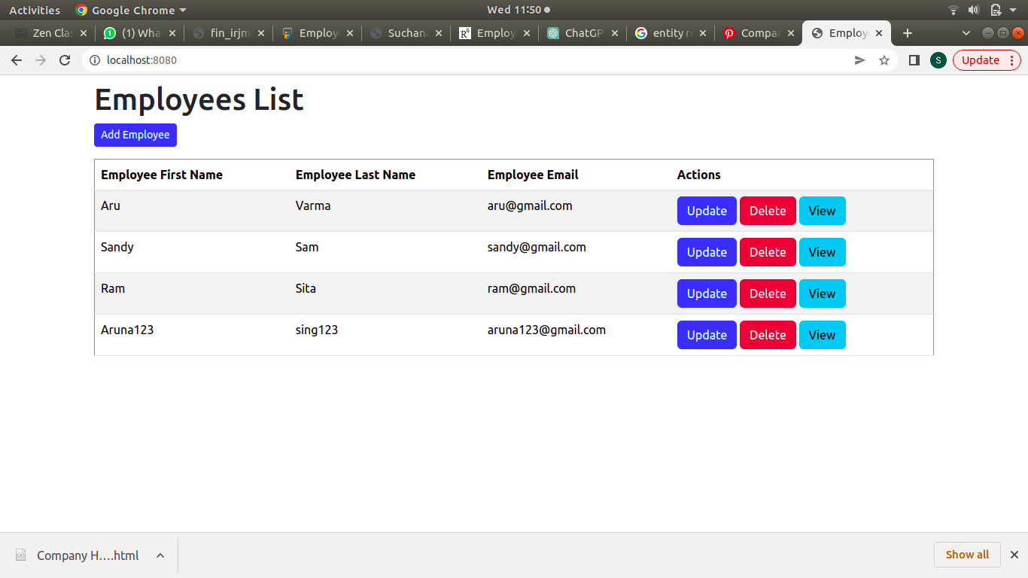

fig:5.1 Home page

9

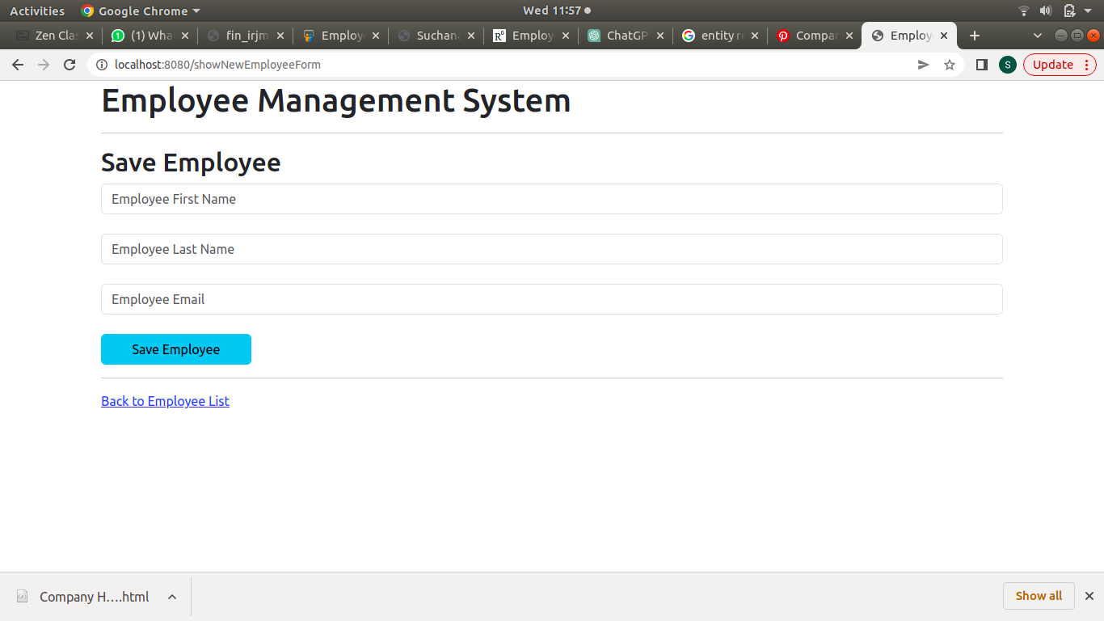

fig:5.2 Add Employee Page

10

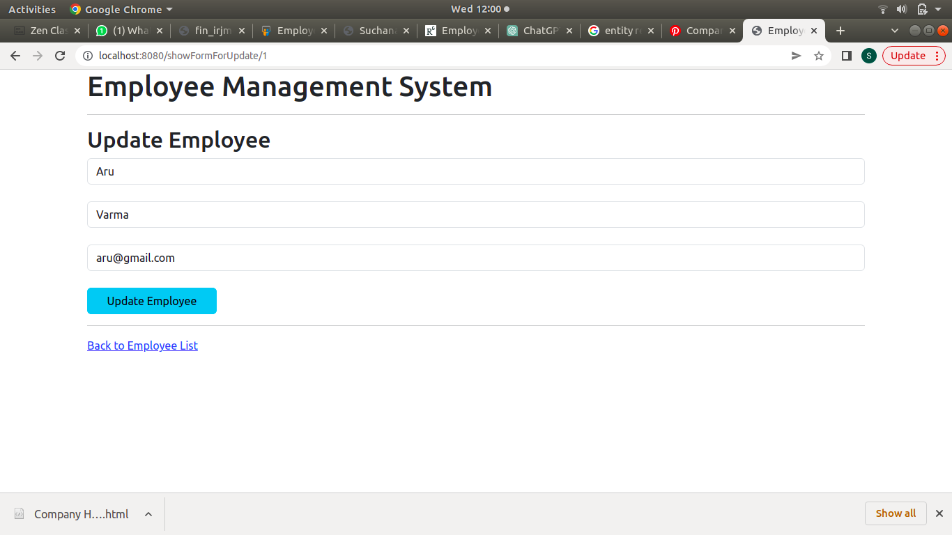

fig:5.3 Update Employee Page

11

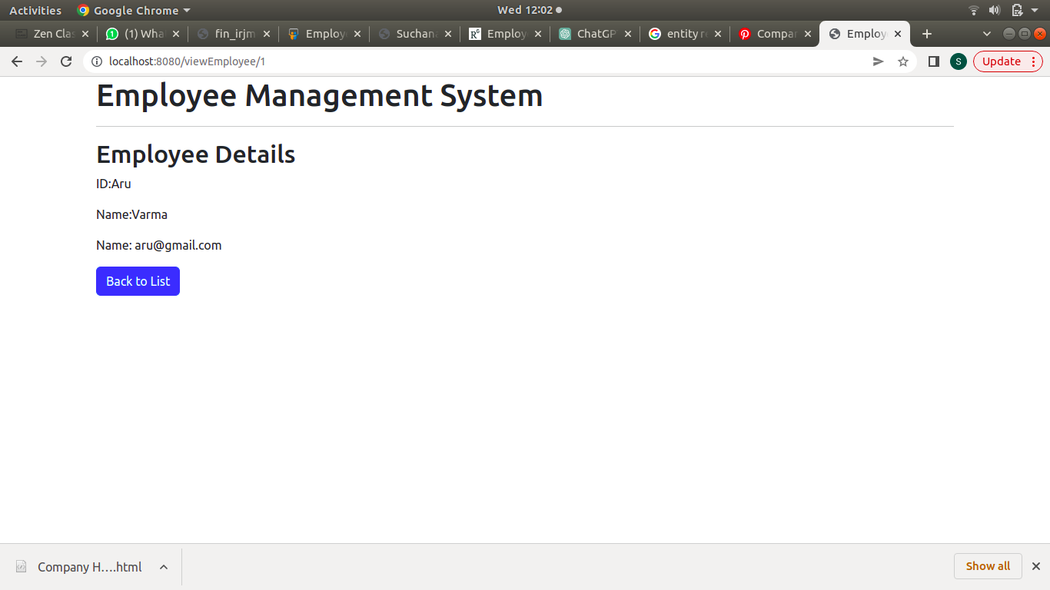

fig:5.4 View Employee Page

12

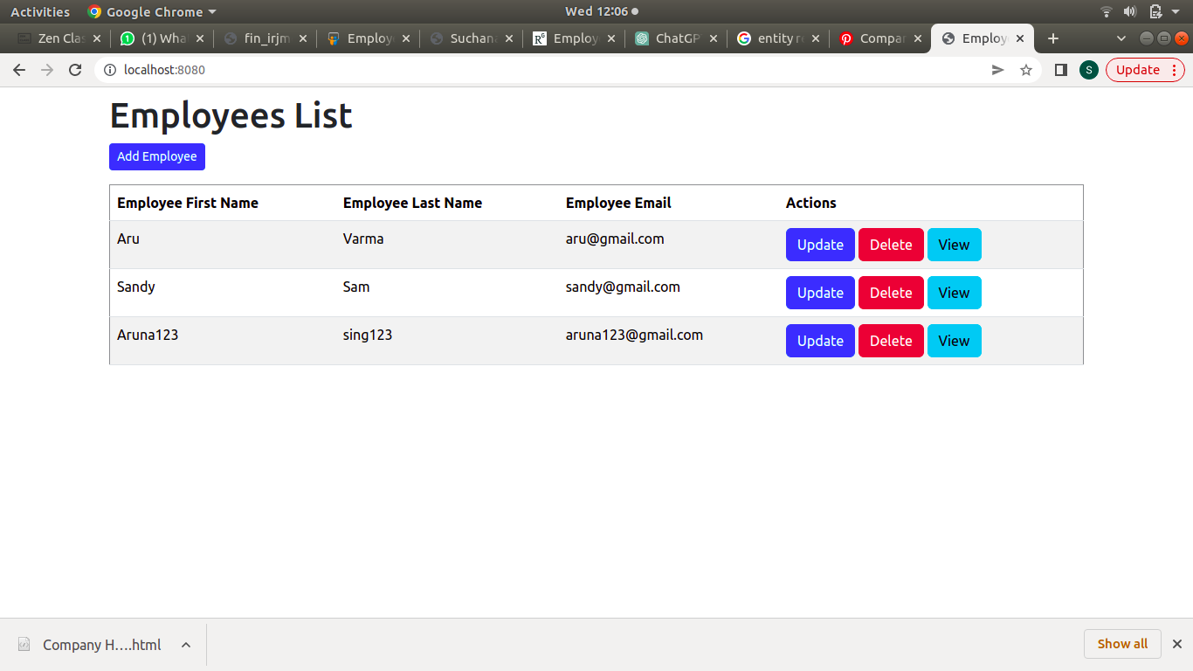

fig:5.5 Delete Employee Page

13

CHAPTER 6

SUMMARY AND CONCLUSION

6.1 Summary of Achievement

We have designed an application that can perform different functionalities and meet the requirements.
Some of the highlights of our application are:

- User friendly: simple and easy to use
- Efficient functioning: capable of producing a result

6.2. Difficulties encountered during project

The entire development of project encountered a little problem. The prime being learning the new functionalities of the application on which the development of the project is based on. A lot of detailed study was required the initial phases of the project development.

6.3. Limitation of the project

- Due to the constraint of resources and time, the size of the project could not be increased.

6.4. Future scope of the project

- The application can be further developed which can include more functionalities, user friendly interfaces.
- Future developers can enhance this product by including documents scanning of employee.
- Ability to send notification through SMS and E-Mail.

14

6.5. CONCLUSION

We have successfully designed and developed a webpage, which is demonstrated in a way so that all the employee details are stored securely, employee can send the leave easily and can generate the pay slip. The system was implemented using web-based technologies which include CSS, JS, HTML, MySQL, and SpringBoot. The system serves as improvement in employee management, maintain accuracy, transparency and highlight the need to integrate advance technology in employee record. The developed system enables the employees to request and track their leave at their own convenient time in timely manner. Superior officers of the institution and administrative department can create leave policies, check transparency and plan activities ahead of time. Employee Leave Management System will provide an effective way of managing the different employee leave requests. The system will eliminate all the problems encountered in the manual method which will help the companies or organization better improve their business operations.

Since this task has been planned only as an undertaking, certain intricacies that do looked by any genuine manual issue like absolute no. of representative, address repetition and so forth are considered in this task.

- But upgrade to the venture can undoubtedly be made without changing the current plan and programming structure.
- Data stockpiling is simpler. Desk work will be decreased and the organization staffs invest more energy on checking the advancement.
- The framework is easy to use and simple to utilize.

15

REFERENCES:

[1] [1] OrangeHRM Open Source, Retrieved: November 4, 2013. From: http://www.orangehrm.com/opensourceproduct-features-pim.shtml [2]
[2] A.S. Syed Navaz, A.S. Syed Fiaz, C. Prabhadevi, V. Sangeetha, S. Gopalakrishnan, “Human Resource Management System”, IOSR Journal of Computer Engineering (IOSR-JCE), Volume 8, Issue 4 (Jan. – Feb. 2013) Page 62-71.
[3] Julie Bulmash, “Human Resource Management and Technology”, Chapter 3 [4] TECH HRM (Human Resource Management System), Retrieved: November 4, 2013. From: http://www.techjetsolutions.com/brochure/TECHHRM.Pdf
[5] Renae Broderick, John W. Boudreau, “Human resource management, information technology, and the competitive edge”, Academy of Management Executive, 1992 Vol. 6 No. 2 http://www.webopedia.com
[6] Avison, D. and Fitzgerald, G. (2003). Information systems Development Methodologies, Techniques and Tools.3rd Edition. McGraw-Hill Education Limited Bershire
[7] Zhiming, L, July 2002, Object-Oriented Software Development with UML Retrieved: July 16th 2010. From: http://www.iist.unu.edu/www/docs/techreports/reports/report259.pdf 67
[8] Juan Manuel Munoz Palacio, Information systems development methodologies for Datadriven Decision Support Systems, 2010,
[9] Deitel, PJ & Deitel, HM, 2008, Internet & World Wide Web How to Program, Dorling Kindersley, India
[10] Web design best practices checklist 2009. Retrieved: October 17, 2009, from: http://terrymorris.net/bestpractices/

16

